GYM MANAGEMENT
PROJECT BY: DEVAYANI MORE
GUIDED BY: MR. SAMEER WARSOLKAR SIR

Abstract:
A Gym Management System is a database solution designed to manage gym operations such as member registration, memberships, trainers, workout sessions, equipment, and payments. It helps store and organize gym data efficiently, reduces manual work and data redundancy, and provides quick access to important information using MySQL.

Email: moredevayani554@gmail.com
Batch ID: T384

GYM MANAGEMENT
Project for my-sql module
- DESCRIPTION :
The Gym Management System is a comprehensive database designed to streamline and manage the daily operations of a gym or fitness centre by organizing data related to members, trainers, membership plans, workout sessions, equipment, and payments. The system uses a relational database structure to maintain these different entities and the relationships between them.
The key components of the database schema are:
• Gym: Contains basic information about the gym, including its name, address, contact details, and location.
• Member: Stores information about gym members, including their names, contact details, age, gender, joining date, and membership status.
• Trainer: Manages information about trainers, including their names, contact details, specialization, experience, and the members assigned to them.
• Membership: Contains details about different membership plans offered by the gym, including plan names, duration, fees, and membership types.
• Workout Session: Tracks workout and training sessions conducted for members, including session dates, timings, workout types, and the trainer assigned to the session.
• Equipment: Maintains information about gym equipment, including equipment names, types, quantities, purchase dates, and their current availability or condition.
• Payment: Stores billing and payment information for gym members, including member ID, membership plan, payment amount, payment date, and payment status.
These tables are interconnected through primary keys and foreign keys to maintain data integrity and establish meaningful relationships between members, trainers, memberships, workout sessions, equipment, and payments. The system provides a structured framework for managing gym memberships, tracking member activities, assigning trainers, monitoring workout sessions, maintaining equipment records, and handling payments.
By using a relational database, the Gym Management System helps gym administrators efficiently manage member records, trainer assignments, membership plans, attendance and workout activities, equipment information, and financial transactions. It reduces manual record-keeping, minimizes data duplication, improves data accuracy, and makes it easier to retrieve and analysis important information using SQL queries.
Overall, the system provides a reliable and organized database solution for managing gym operations, improving administrative efficiency and supporting better management of members, trainers, fitness activities, and payments.

- ER DIAGRAM :

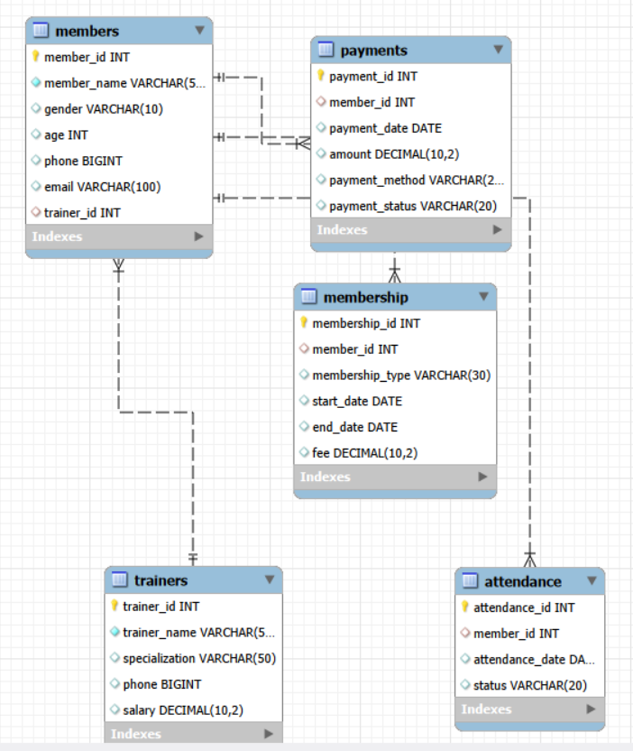

- TABLE DESCRIPTION :
- Attendance Table
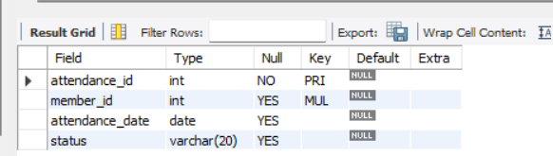
- Members Table
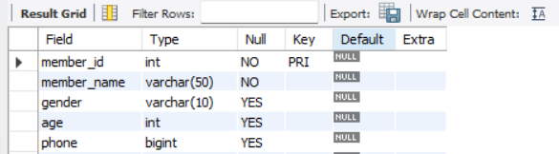
- Membership Table
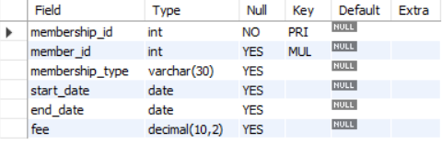
- Payment Table
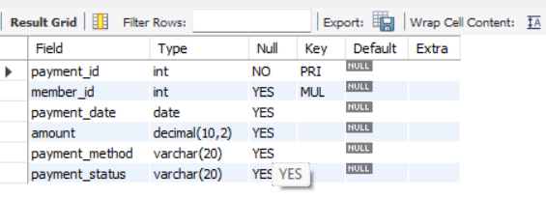
- Trainers Table
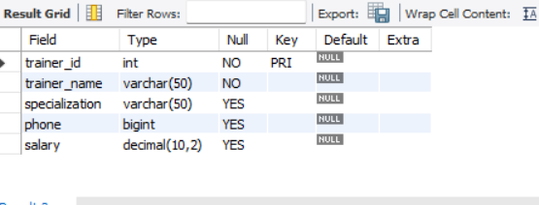
- COMMANDS :

CREATE DATABASE GYM_MANAGEMENT;

-- CREATE TRAINERS TABLE --
use gym_management;
CREATE TABLE trainers (
trainer_id INT PRIMARY KEY,
trainer_name VARCHAR(50) NOT NULL,
specialization VARCHAR(50),
phone BIGINT,
salary DECIMAL(10,2)
);
-- CREATE MEMBERS TABLE --
CREATE TABLE members (
member_id INT PRIMARY KEY,
member_name VARCHAR(50) NOT NULL,
gender VARCHAR(10),
age INT,
phone BIGINT,
email VARCHAR(100),
trainer_id INT,
FOREIGN KEY (trainer_id) REFERENCES trainers(trainer_id)
);

-- CREATE MEMBERSHIP TABLE --
CREATE TABLE membership (
membership_id INT PRIMARY KEY,
member_id INT,
membership_type VARCHAR(30),
start_date DATE,
end_date DATE,
fee DECIMAL(10,2),
FOREIGN KEY (member_id) REFERENCES members(member_id)
);

-- CREATE PAYMENTS TABLE --
CREATE TABLE payments (
payment_id INT PRIMARY KEY,
member_id INT,
payment_date DATE,
amount DECIMAL(10,2),
payment_method VARCHAR(20),
payment_status VARCHAR(20),
FOREIGN KEY (member_id) REFERENCES members(member_id)
);

-- CREATE ATTENDANCE TABLE --
CREATE TABLE attendance (
attendance_id INT PRIMARY KEY,
member_id INT,
attendance_date DATE,
status VARCHAR(20),
FOREIGN KEY (member_id) REFERENCES members(member_id)
);

-- INSERTING DATA INTO TRAINERS TABLE --
INSERT INTO trainers
(trainer_id, trainer_name, specialization, phone, salary)
VALUES
(101, 'Rahul Sharma', 'Weight Training', 9876500001, 35000.00),
(102, 'Priya Mehta', 'Yoga', 9876500002, 32000.00),
(103, 'Amit Patil', 'Cardio', 9876500003, 30000.00),
(104, 'Sukanya Mulay', 'CrossFit', 9876500004, 38000.00),
(105, 'Vikas Singh', 'Strength Training', 9876500005, 36000.00),
(106, 'Priyanka Patil', 'Zumba', 9876500006, 31000.00),
(107, 'Mrunmayee Hadekar', 'Functional Training', 9876500007, 34000.00),
(108, 'Pooja Bhatt', 'Pilates', 9876500008, 33000.00),
(109, 'Karan Malhotra', 'Bodybuilding', 9876500009, 40000.00),
(110, 'Anjali Rao', 'Fitness Training', 9876500010, 37000.00);

-- INSERTING DATA INTO MEMEBERS --
INSERT INTO members
(member_id, member_name, gender, age, phone, email, trainer_id)
VALUES
(1, 'Aarav Shah', 'Male', 25, 9000000001, 'aarav.shah@gmail.com', 101),
(2, 'Ananya More', 'Female', 23, 9000000002, 'ananya.more@gmail.com', 102),
(3, 'Rohan Patil', 'Male', 30, 9000000003, 'rohan.patil@gmail.com', 103),
(4, 'Sneha Desai', 'Female', 27, 9000000004, 'sneha.desai@gmail.com', 104),
(5, 'Karan Joshi', 'Male', 29, 9000000005, 'karan.joshi@gmail.com', 105),
(6, 'Neha Sharma', 'Female', 24, 9000000006, 'neha.sharma@gmail.com', 106),
(7, 'Aditya Kulkarni', 'Male', 32, 9000000007, 'aditya.kulkarni@gmail.com', 107),
(8, 'Pooja Singh', 'Female', 26, 9000000008, 'pooja.singh@gmail.com', 108),
(9, 'Vivek Mehta', 'Male', 35, 9000000009, 'vivek.mehta@gmail.com', 109),
(10, 'Isha Rao', 'Female', 28, 9000000010, 'isha.rao@gmail.com', 110),

(11, 'Arjun Verma', 'Male', 31, 9000000011, 'arjun.verma@gmail.com', 101),
(12, 'Kavya Shah', 'Female', 22, 9000000012, 'kavya.shah@gmail.com', 102),
(13, 'Siddharth Patil', 'Male', 27, 9000000013, 'siddharth.patil@gmail.com', 103),
(14, 'Riya Joshi', 'Female', 25, 9000000014, 'riya.joshi@gmail.com', 104),
(15, 'Manish Singh', 'Male', 34, 9000000015, 'manish.singh@gmail.com', 105),
(16, 'Simran Kapoor', 'Female', 29, 9000000016, 'simran.kapoor@gmail.com', 106),
(17, 'Akash Desai', 'Male', 26, 9000000017, 'akash.desai@gmail.com', 107),
(18, 'Meera Nair', 'Female', 30, 9000000018, 'meera.nair@gmail.com', 108),
(19, 'Raj Malhotra', 'Male', 38, 9000000019, 'raj.malhotra@gmail.com', 109),
(20, 'Tanvi Rao', 'Female', 24, 9000000020, 'tanvi.rao@gmail.com', 110),
(21, 'Yash Sharma', 'Male', 28, 9000000021, 'yash.sharma@gmail.com', 101),
(22, 'Nisha More', 'Female', 27, 9000000022, 'nisha.more@gmail.com', 102),
(23, 'Harsh Patil', 'Male', 33, 9000000023, 'harsh.patil@gmail.com', 103),
(24, 'Mitali Desai', 'Female', 26, 9000000024, 'mitali.desai@gmail.com', 104),
(25, 'Ritesh Joshi', 'Male', 36, 9000000025, 'ritesh.joshi@gmail.com', 105),
(26, 'Aditi Singh', 'Female', 23, 9000000026, 'aditi.singh@gmail.com', 106),
(27, 'Saurabh Kapoor', 'Male', 31, 9000000027, 'saurabh.kapoor@gmail.com', 107),
(28, 'Shruti Nair', 'Female', 29, 9000000028, 'shruti.nair@gmail.com', 108),
(29, 'Vishal Rao', 'Male', 40, 9000000029, 'vishal.rao@gmail.com', 109),
(30, 'Diya Mehta', 'Female', 21, 9000000030, 'diya.mehta@gmail.com', 110),

(31, 'Mohit Sharma', 'Male', 37, 9000000031, 'mohit.sharma@gmail.com', 101),
(32, 'Pallavi More', 'Female', 28, 9000000032, 'pallavi.more@gmail.com', 102),
(33, 'Nikhil Patil', 'Male', 30, 9000000033, 'nikhil.patil@gmail.com', 103),
(34, 'Sakshi Desai', 'Female', 25, 9000000034, 'sakshi.desai@gmail.com', 104),
(35, 'Abhishek Joshi', 'Male', 32, 9000000035, 'abhishek.joshi@gmail.com', 105),
(36, 'Komal Singh', 'Female', 27, 9000000036, 'komal.singh@gmail.com', 106),
(37, 'Varun Kapoor', 'Male', 29, 9000000037, 'varun.kapoor@gmail.com', 107),
(38, 'Radhika Nair', 'Female', 34, 9000000038, 'radhika.nair@gmail.com', 108),
(39, 'Gaurav Malhotra', 'Male', 41, 9000000039, 'gaurav.malhotra@gmail.com', 109),
(40, 'Ayesha Rao', 'Female', 26, 9000000040, 'ayesha.rao@gmail.com', 110),
(41, 'Dev Sharma', 'Male', 24, 9000000041, 'dev.sharma@gmail.com', 101),
(42, 'Shreya Mehta', 'Female', 22, 9000000042, 'shreya.mehta@gmail.com', 102),
(43, 'Omkar Patil', 'Male', 35, 9000000043, 'omkar.patil@gmail.com', 103),
(44, 'Ishita Joshi', 'Female', 31, 9000000044, 'ishita.joshi@gmail.com', 104),
(45, 'Sameer Singh', 'Male', 39, 9000000045, 'sameer.singh@gmail.com', 105),
(46, 'Payal Kapoor', 'Female', 28, 9000000046, 'payal.kapoor@gmail.com', 106),
(47, 'Nitin Desai', 'Male', 33, 9000000047, 'nitin.desai@gmail.com', 107),
(48, 'Mansi Nair', 'Female', 25, 9000000048, 'mansi.nair@gmail.com', 108),
(49, 'Rahul Malhotra', 'Male', 36, 9000000049, 'rahul.malhotra@gmail.com', 109),
(50, 'Kriti Rao', 'Female', 30, 9000000050, 'kriti.rao@gmail.com', 110);

-- INSERTING DATA INTO MEMEBERSHIP --
INSERT INTO membership
(membership_id, member_id, membership_type, start_date, end_date, fee)
VALUES
(201, 1, 'Gold', '2026-01-01', '2026-12-31', 18000.00),
(202, 2, 'Silver', '2026-01-05', '2026-07-04', 12000.00),
(203, 3, 'Platinum', '2026-01-10', '2027-01-09', 25000.00),
(204, 4, 'Gold', '2026-01-15', '2027-01-14', 18000.00),
(205, 5, 'Silver', '2026-01-20', '2026-07-19', 12000.00),
(206, 6, 'Platinum', '2026-02-01', '2027-01-31', 25000.00),
(207, 7, 'Gold', '2026-02-05', '2027-02-04', 18000.00),
(208, 8, 'Silver', '2026-02-10', '2026-08-09', 12000.00),
(209, 9, 'Platinum', '2026-02-15', '2027-02-14', 25000.00),
(210, 10, 'Gold', '2026-02-20', '2027-02-19', 18000.00),

(211, 11, 'Silver', '2026-03-01', '2026-08-31', 12000.00),
(212, 12, 'Gold', '2026-03-05', '2027-03-04', 18000.00),
(213, 13, 'Platinum', '2026-03-10', '2027-03-09', 25000.00),
(214, 14, 'Silver', '2026-03-15', '2026-09-14', 12000.00),
(215, 15, 'Gold', '2026-03-20', '2027-03-19', 18000.00),
(216, 16, 'Platinum', '2026-04-01', '2027-03-31', 25000.00),
(217, 17, 'Gold', '2026-04-05', '2027-04-04', 18000.00),
(218, 18, 'Silver', '2026-04-10', '2026-10-09', 12000.00),
(219, 19, 'Platinum', '2026-04-15', '2027-04-14', 25000.00),
(220, 20, 'Gold', '2026-04-20', '2027-04-19', 18000.00),

(221, 21, 'Silver', '2026-05-01', '2026-10-31', 12000.00),
(222, 22, 'Gold', '2026-05-05', '2027-05-04', 18000.00),
(223, 23, 'Platinum', '2026-05-10', '2027-05-09', 25000.00),
(224, 24, 'Silver', '2026-05-15', '2026-11-14', 12000.00),
(225, 25, 'Gold', '2026-05-20', '2027-05-19', 18000.00),
(226, 26, 'Platinum', '2026-06-01', '2027-05-31', 25000.00),
(227, 27, 'Gold', '2026-06-05', '2027-06-04', 18000.00),
(228, 28, 'Silver', '2026-06-10', '2026-12-09', 12000.00),
(229, 29, 'Platinum', '2026-06-15', '2027-06-14', 25000.00),
(230, 30, 'Gold', '2026-06-20', '2027-06-19', 18000.00),

(231, 31, 'Silver', '2026-07-01', '2026-12-31', 12000.00),
(232, 32, 'Gold', '2026-07-05', '2027-07-04', 18000.00),
(233, 33, 'Platinum', '2026-07-10', '2027-07-09', 25000.00),
(234, 34, 'Silver', '2026-07-15', '2027-01-14', 12000.00),
(235, 35, 'Gold', '2026-07-20', '2027-07-19', 18000.00),
(236, 36, 'Platinum', '2026-08-01', '2027-07-31', 25000.00),
(237, 37, 'Gold', '2026-08-05', '2027-08-04', 18000.00),
(238, 38, 'Silver', '2026-08-10', '2027-02-09', 12000.00),
(239, 39, 'Platinum', '2026-08-15', '2027-08-14', 25000.00),
(240, 40, 'Gold', '2026-08-18', '2027-08-17', 18000.00),

(241, 41, 'Silver', '2026-08-01', '2027-01-31', 12000.00),
(242, 42, 'Gold', '2026-08-02', '2027-08-01', 18000.00),
(243, 43, 'Platinum', '2026-08-03', '2027-08-02', 25000.00),
(244, 44, 'Silver', '2026-08-04', '2027-02-03', 12000.00),
(245, 45, 'Gold', '2026-08-05', '2027-08-04', 18000.00),
(246, 46, 'Platinum', '2026-08-06', '2027-08-05', 25000.00),
(247, 47, 'Gold', '2026-08-07', '2027-08-06', 18000.00),
(248, 48, 'Silver', '2026-08-08', '2027-02-07', 12000.00),
(249, 49, 'Platinum', '2026-08-09', '2027-08-08', 25000.00),
(250, 50, 'Gold', '2026-08-10', '2027-08-09', 18000.00);

-- INSEERTING DATA INTO PAYMENTS --
INSERT INTO payments
(payment_id, member_id, payment_date, amount, payment_method, payment_status)
VALUES
(301, 1, '2026-01-01', 18000.00, 'UPI', 'Paid'),
(302, 2, '2026-01-05', 12000.00, 'Card', 'Paid'),
(303, 3, '2026-01-10', 25000.00, 'Cash', 'Paid'),
(304, 4, '2026-01-15', 18000.00, 'UPI', 'Paid'),
(305, 5, '2026-01-20', 12000.00, 'Card', 'Pending'),
(306, 6, '2026-02-01', 25000.00, 'UPI', 'Paid'),
(307, 7, '2026-02-05', 18000.00, 'Cash', 'Paid'),
(308, 8, '2026-02-10', 12000.00, 'Card', 'Paid'),
(309, 9, '2026-02-15', 25000.00, 'UPI', 'Paid'),
(310, 10, '2026-02-20', 18000.00, 'Cash', 'Pending'),

(311, 11, '2026-03-01', 12000.00, 'UPI', 'Paid'),
(312, 12, '2026-03-05', 18000.00, 'Card', 'Paid'),
(313, 13, '2026-03-10', 25000.00, 'UPI', 'Paid'),
(314, 14, '2026-03-15', 12000.00, 'Cash', 'Pending'),
(315, 15, '2026-03-20', 18000.00, 'Card', 'Paid'),
(316, 16, '2026-04-01', 25000.00, 'UPI', 'Paid'),
(317, 17, '2026-04-05', 18000.00, 'Cash', 'Paid'),
(318, 18, '2026-04-10', 12000.00, 'Card', 'Paid'),
(319, 19, '2026-04-15', 25000.00, 'UPI', 'Pending'),
(320, 20, '2026-04-20', 18000.00, 'Cash', 'Paid'),

(321, 21, '2026-05-01', 12000.00, 'UPI', 'Paid'),
(322, 22, '2026-05-05', 18000.00, 'Card', 'Paid'),
(323, 23, '2026-05-10', 25000.00, 'Cash', 'Paid'),
(324, 24, '2026-05-15', 12000.00, 'UPI', 'Pending'),
(325, 25, '2026-05-20', 18000.00, 'Card', 'Paid'),
(326, 26, '2026-06-01', 25000.00, 'UPI', 'Paid'),
(327, 27, '2026-06-05', 18000.00, 'Cash', 'Paid'),
(328, 28, '2026-06-10', 12000.00, 'Card', 'Paid'),
(329, 29, '2026-06-15', 25000.00, 'UPI', 'Pending'),
(330, 30, '2026-06-20', 18000.00, 'Cash', 'Paid'),

(331, 31, '2026-07-01', 12000.00, 'UPI', 'Paid'),
(332, 32, '2026-07-05', 18000.00, 'Card', 'Paid'),
(333, 33, '2026-07-10', 25000.00, 'Cash', 'Paid'),
(334, 34, '2026-07-15', 12000.00, 'UPI', 'Pending'),
(335, 35, '2026-07-20', 18000.00, 'Card', 'Paid'),
(336, 36, '2026-08-01', 25000.00, 'UPI', 'Paid'),
(337, 37, '2026-08-05', 18000.00, 'Cash', 'Paid'),
(338, 38, '2026-08-10', 12000.00, 'Card', 'Paid'),
(339, 39, '2026-08-15', 25000.00, 'UPI', 'Pending'),
(340, 40, '2026-08-18', 18000.00, 'Cash', 'Paid');

-- INSERTING DATA INTO ATTENDANCE --
INSERT INTO attendance
(attendance_id, member_id, attendance_date, status)
VALUES
(401, 1, '2026-08-01', 'Present'),
(402, 2, '2026-08-01', 'Present'),
(403, 3, '2026-08-01', 'Absent'),
(404, 4, '2026-08-01', 'Present'),
(405, 5, '2026-08-01', 'Present'),
(406, 6, '2026-08-01', 'Absent'),
(407, 7, '2026-08-01', 'Present'),
(408, 8, '2026-08-01', 'Present'),
(409, 9, '2026-08-01', 'Present'),
(410, 10, '2026-08-01', 'Absent'),

(411, 11, '2026-08-02', 'Present'),
(412, 12, '2026-08-02', 'Absent'),
(413, 13, '2026-08-02', 'Present'),
(414, 14, '2026-08-02', 'Present'),
(415, 15, '2026-08-02', 'Absent'),
(416, 16, '2026-08-02', 'Present'),
(417, 17, '2026-08-02', 'Present'),
(418, 18, '2026-08-02', 'Absent'),
(419, 19, '2026-08-02', 'Present'),
(420, 20, '2026-08-02', 'Present'),

(421, 21, '2026-08-03', 'Present'),
(422, 22, '2026-08-03', 'Present'),
(423, 23, '2026-08-03', 'Absent'),
(424, 24, '2026-08-03', 'Present'),
(425, 25, '2026-08-03', 'Present'),
(426, 26, '2026-08-03', 'Absent'),
(427, 27, '2026-08-03', 'Present'),
(428, 28, '2026-08-03', 'Present'),
(429, 29, '2026-08-03', 'Absent'),
(430, 30, '2026-08-03', 'Present'),

(431, 31, '2026-08-04', 'Absent'),
(432, 32, '2026-08-04', 'Present'),
(433, 33, '2026-08-04', 'Present'),
(434, 34, '2026-08-04', 'Absent'),
(435, 35, '2026-08-04', 'Present'),
(436, 36, '2026-08-04', 'Present'),
(437, 37, '2026-08-04', 'Absent'),
(438, 38, '2026-08-04', 'Present'),
(439, 39, '2026-08-04', 'Present'),
(440, 40, '2026-08-04', 'Absent'),

(441, 41, '2026-08-05', 'Present'),
(442, 42, '2026-08-05', 'Present'),
(443, 43, '2026-08-05', 'Present'),
(444, 44, '2026-08-05', 'Absent'),
(445, 45, '2026-08-05', 'Present'),
(446, 46, '2026-08-05', 'Absent'),
(447, 47, '2026-08-05', 'Present'),
(448, 48, '2026-08-05', 'Present'),
(449, 49, '2026-08-05', 'Absent'),
(450, 50, '2026-08-05', 'Present');

-- INSERTING MORE RECORDS --
INSERT INTO attendance
(attendance_id, member_id, attendance_date, status)
VALUES
(451, 1, '2026-08-06', 'Present'),
(452, 2, '2026-08-06', 'Present'),
(453, 3, '2026-08-06', 'Absent'),
(454, 4, '2026-08-06', 'Present'),
(455, 5, '2026-08-06', 'Present'),
(456, 6, '2026-08-06', 'Absent'),
(457, 7, '2026-08-06', 'Present'),
(458, 8, '2026-08-06', 'Present'),
(459, 9, '2026-08-06', 'Present'),
(460, 10, '2026-08-06', 'Absent'),

(461, 11, '2026-08-07', 'Present'),
(462, 12, '2026-08-07', 'Absent'),
(463, 13, '2026-08-07', 'Present'),
(464, 14, '2026-08-07', 'Present'),
(465, 15, '2026-08-07', 'Present'),
(466, 16, '2026-08-07', 'Absent'),
(467, 17, '2026-08-07', 'Present'),
(468, 18, '2026-08-07', 'Present'),
(469, 19, '2026-08-07', 'Absent'),
(470, 20, '2026-08-07', 'Present'),

(471, 21, '2026-08-08', 'Present'),
(472, 22, '2026-08-08', 'Present'),
(473, 23, '2026-08-08', 'Absent'),
(474, 24, '2026-08-08', 'Present'),
(475, 25, '2026-08-08', 'Present'),
(476, 26, '2026-08-08', 'Present'),
(477, 27, '2026-08-08', 'Absent'),
(478, 28, '2026-08-08', 'Present'),
(479, 29, '2026-08-08', 'Present'),
(480, 30, '2026-08-08', 'Absent'),

(481, 31, '2026-08-09', 'Present'),
(482, 32, '2026-08-09', 'Present'),
(483, 33, '2026-08-09', 'Present'),
(484, 34, '2026-08-09', 'Absent'),
(485, 35, '2026-08-09', 'Present'),
(486, 36, '2026-08-09', 'Absent'),
(487, 37, '2026-08-09', 'Present'),
(488, 38, '2026-08-09', 'Present'),
(489, 39, '2026-08-09', 'Absent'),
(490, 40, '2026-08-09', 'Present'),

(491, 41, '2026-08-10', 'Present'),
(492, 42, '2026-08-10', 'Absent'),
(493, 43, '2026-08-10', 'Present'),
(494, 44, '2026-08-10', 'Present'),
(495, 45, '2026-08-10', 'Present'),
(496, 46, '2026-08-10', 'Absent'),
(497, 47, '2026-08-10', 'Present'),
(498, 48, '2026-08-10', 'Present'),
(499, 49, '2026-08-10', 'Present'),
(500, 50, '2026-08-10', 'Absent'),

(501, 1, '2026-08-11', 'Present'),
(502, 2, '2026-08-11', 'Absent'),
(503, 3, '2026-08-11', 'Present'),
(504, 4, '2026-08-11', 'Present'),
(505, 5, '2026-08-11', 'Present'),
(506, 6, '2026-08-11', 'Absent'),
(507, 7, '2026-08-11', 'Present'),
(508, 8, '2026-08-11', 'Present'),
(509, 9, '2026-08-11', 'Absent'),
(510, 10, '2026-08-11', 'Present'),

(511, 11, '2026-08-12', 'Present'),
(512, 12, '2026-08-12', 'Present'),
(513, 13, '2026-08-12', 'Absent'),
(514, 14, '2026-08-12', 'Present'),
(515, 15, '2026-08-12', 'Present'),
(516, 16, '2026-08-12', 'Present'),
(517, 17, '2026-08-12', 'Absent'),
(518, 18, '2026-08-12', 'Present'),
(519, 19, '2026-08-12', 'Present'),
(520, 20, '2026-08-12', 'Absent'),

(521, 21, '2026-08-13', 'Present'),
(522, 22, '2026-08-13', 'Present'),
(523, 23, '2026-08-13', 'Present'),
(524, 24, '2026-08-13', 'Absent'),
(525, 25, '2026-08-13', 'Present'),
(526, 26, '2026-08-13', 'Present'),
(527, 27, '2026-08-13', 'Absent'),
(528, 28, '2026-08-13', 'Present'),
(529, 29, '2026-08-13', 'Present'),
(530, 30, '2026-08-13', 'Present'),

(531, 31, '2026-08-14', 'Absent'),
(532, 32, '2026-08-14', 'Present'),
(533, 33, '2026-08-14', 'Present'),
(534, 34, '2026-08-14', 'Present'),
(535, 35, '2026-08-14', 'Absent'),
(536, 36, '2026-08-14', 'Present'),
(537, 37, '2026-08-14', 'Present'),
(538, 38, '2026-08-14', 'Absent'),
(539, 39, '2026-08-14', 'Present'),
(540, 40, '2026-08-14', 'Present'),

(541, 41, '2026-08-15', 'Present'),
(542, 42, '2026-08-15', 'Present'),
(543, 43, '2026-08-15', 'Absent'),
(544, 44, '2026-08-15', 'Present'),
(545, 45, '2026-08-15', 'Present'),
(546, 46, '2026-08-15', 'Absent'),
(547, 47, '2026-08-15', 'Present'),
(548, 48, '2026-08-15', 'Present'),
(549, 49, '2026-08-15', 'Absent'),
(550, 50, '2026-08-15', 'Present'),

(551, 1, '2026-08-16', 'Present'),
(552, 2, '2026-08-16', 'Present'),
(553, 3, '2026-08-16', 'Absent'),
(554, 4, '2026-08-16', 'Present'),
(555, 5, '2026-08-16', 'Present'),
(556, 6, '2026-08-16', 'Present'),
(557, 7, '2026-08-16', 'Absent'),
(558, 8, '2026-08-16', 'Present'),
(559, 9, '2026-08-16', 'Present'),
(560, 10, '2026-08-16', 'Absent'),

(561, 11, '2026-08-17', 'Present'),
(562, 12, '2026-08-17', 'Absent'),
(563, 13, '2026-08-17', 'Present'),
(564, 14, '2026-08-17', 'Present'),
(565, 15, '2026-08-17', 'Absent'),
(566, 16, '2026-08-17', 'Present'),
(567, 17, '2026-08-17', 'Present'),
(568, 18, '2026-08-17', 'Absent'),
(569, 19, '2026-08-17', 'Present'),
(570, 20, '2026-08-17', 'Present'),

(571, 21, '2026-08-18', 'Present'),
(572, 22, '2026-08-18', 'Present'),
(573, 23, '2026-08-18', 'Absent'),
(574, 24, '2026-08-18', 'Present'),
(575, 25, '2026-08-18', 'Present'),
(576, 26, '2026-08-18', 'Absent'),
(577, 27, '2026-08-18', 'Present'),
(578, 28, '2026-08-18', 'Present'),
(579, 29, '2026-08-18', 'Present'),
(580, 30, '2026-08-18', 'Absent'),

(581, 31, '2026-08-19', 'Present'),
(582, 32, '2026-08-19', 'Absent'),
(583, 33, '2026-08-19', 'Present'),
(584, 34, '2026-08-19', 'Present'),
(585, 35, '2026-08-19', 'Present'),
(586, 36, '2026-08-19', 'Absent'),
(587, 37, '2026-08-19', 'Present'),
(588, 38, '2026-08-19', 'Present'),
(589, 39, '2026-08-19', 'Absent'),
(590, 40, '2026-08-19', 'Present'),

(591, 41, '2026-08-20', 'Present'),
(592, 42, '2026-08-20', 'Present'),
(593, 43, '2026-08-20', 'Present'),
(594, 44, '2026-08-20', 'Absent'),
(595, 45, '2026-08-20', 'Present'),
(596, 46, '2026-08-20', 'Present'),
(597, 47, '2026-08-20', 'Absent'),
(598, 48, '2026-08-20', 'Present'),
(599, 49, '2026-08-20', 'Present'),
(600, 50, '2026-08-20', 'Absent'),

(601, 1, '2026-08-21', 'Present'),
(602, 2, '2026-08-21', 'Absent'),
(603, 3, '2026-08-21', 'Present'),
(604, 4, '2026-08-21', 'Present'),
(605, 5, '2026-08-21', 'Absent'),
(606, 6, '2026-08-21', 'Present'),
(607, 7, '2026-08-21', 'Present'),
(608, 8, '2026-08-21', 'Absent'),
(609, 9, '2026-08-21', 'Present'),
(610, 10, '2026-08-21', 'Present');

- JOINS

Q1. List all members along with their trainer names

SELECT
m.member_name,
t.trainer_name,
t.specialization
FROM members m
JOIN trainers t
ON m.trainer_id = t.trainer_id;

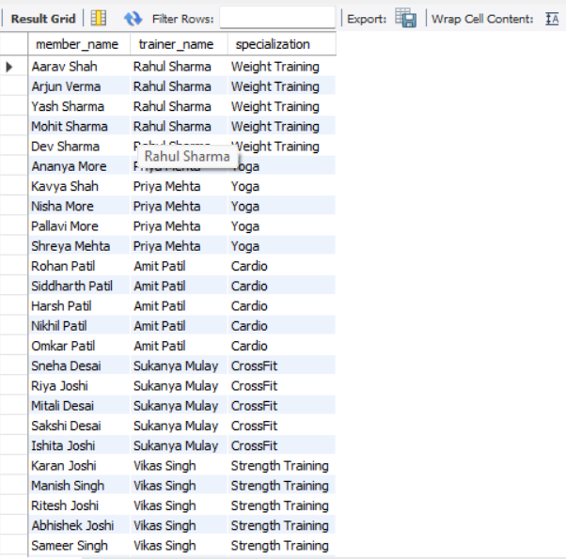
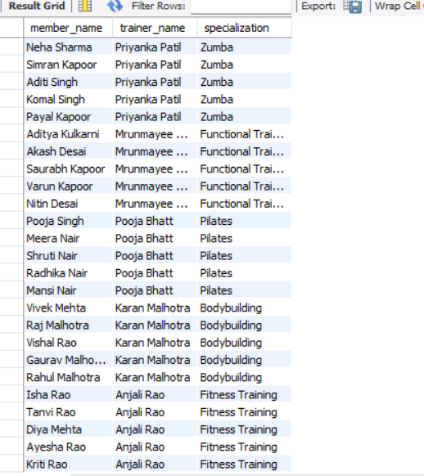

Q2. List members along with their membership type

SELECT
m.member_name,
ms.membership_type,
ms.start_date,
ms.end_date,
ms.fee
FROM members m
JOIN membership ms
ON m.member_id = ms.member_id;

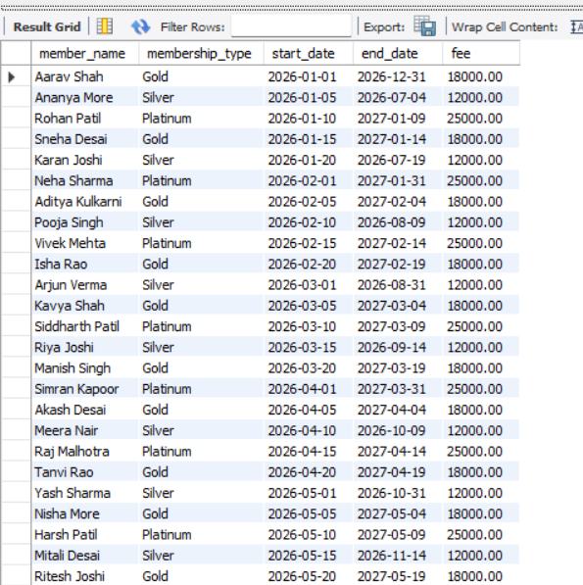
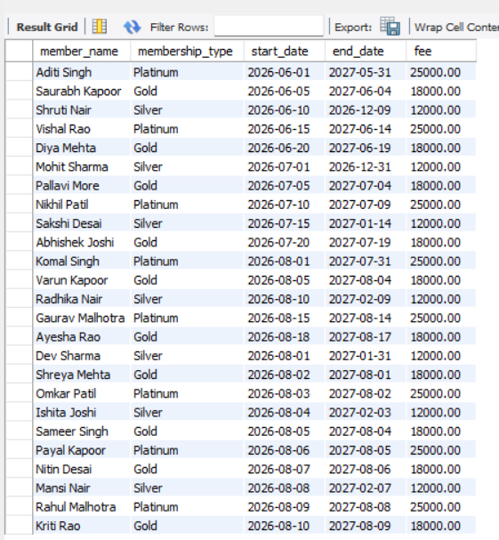

Q3. List members and their payment details

SELECT
m.member_name,
p.payment_date,
p.amount,
p.payment_method,
p.payment_status
FROM members m
JOIN payments p
ON m.member_id = p.member_id;

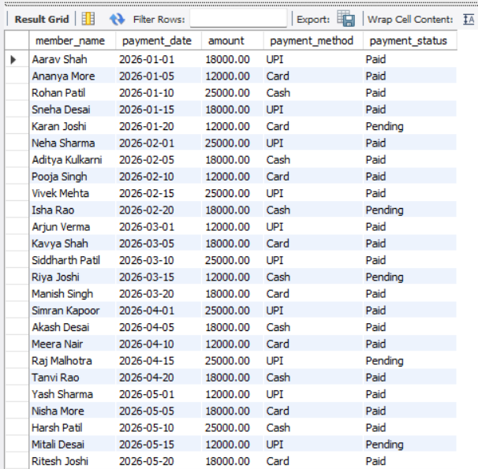
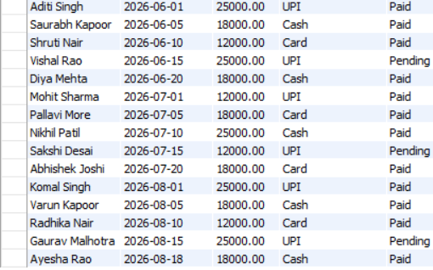

Q4. List members and their attendance

SELECT
m.member_name,
a.attendance_date,
a.status
FROM members m
JOIN attendance a
ON m.member_id = a.member_id;

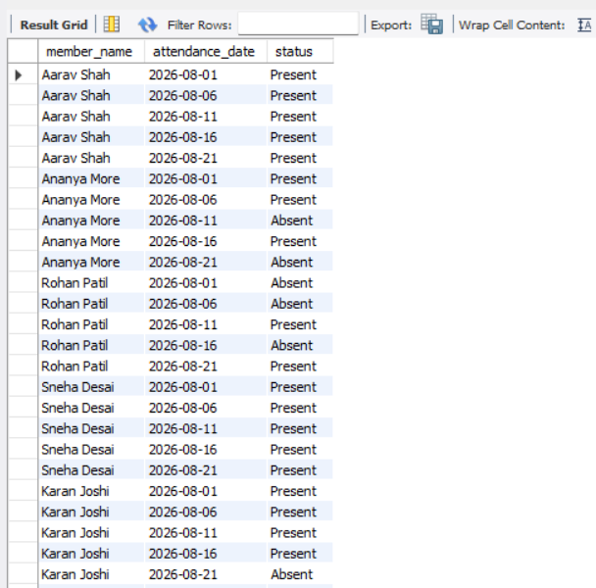
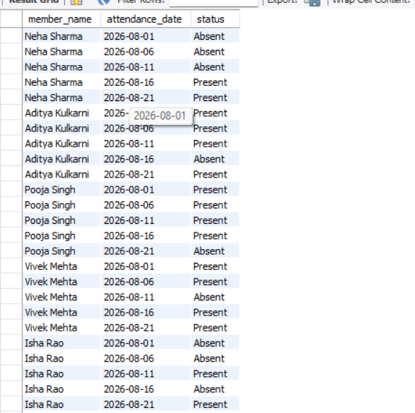
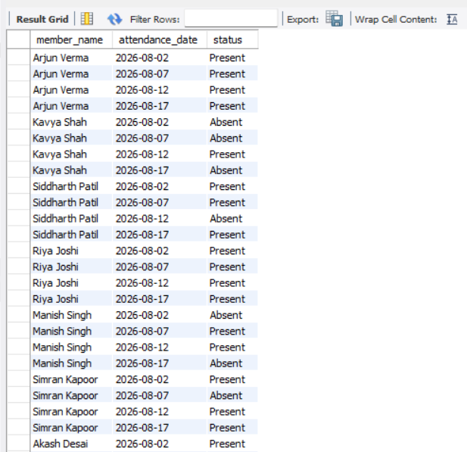
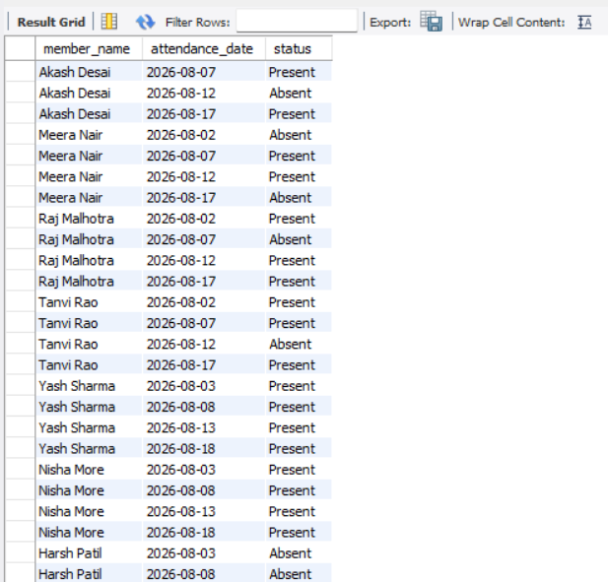
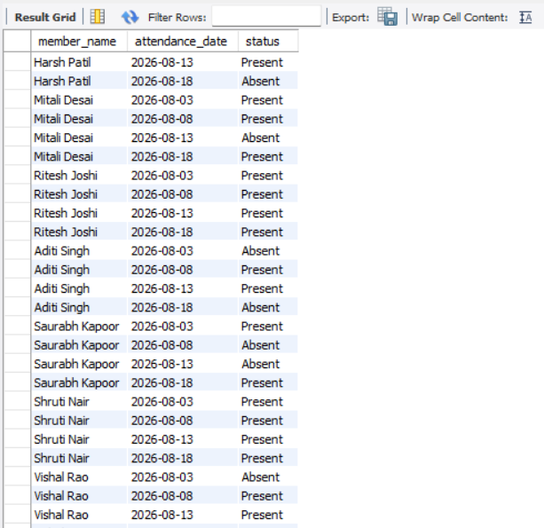
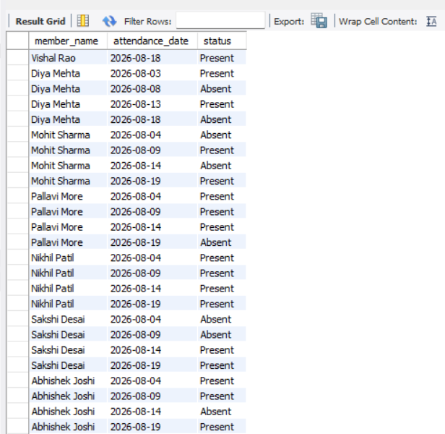
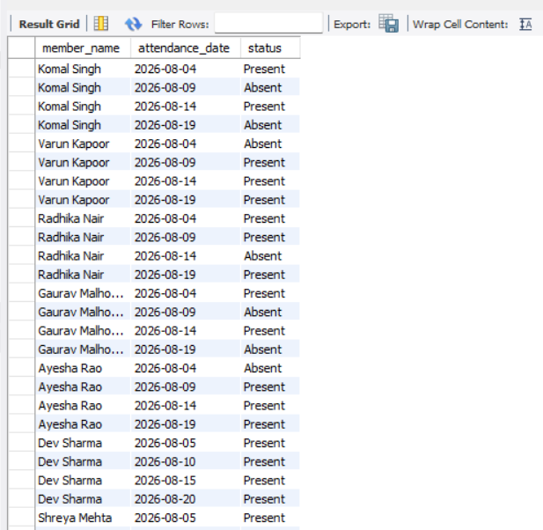
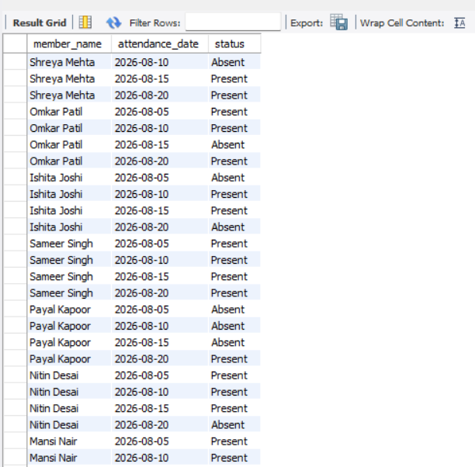
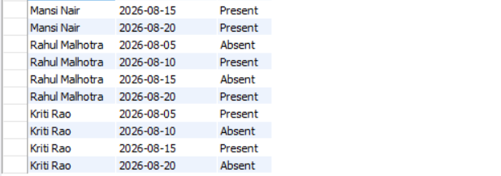

Q5. Get members with their trainer and membership details

SELECT
m.member_name,
t.trainer_name,
ms.membership_type,
ms.fee
FROM members m
JOIN trainers t
ON m.trainer_id = t.trainer_id
JOIN membership ms
ON m.member_id = ms.member_id;

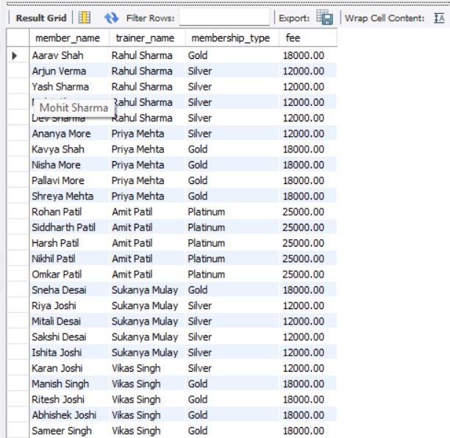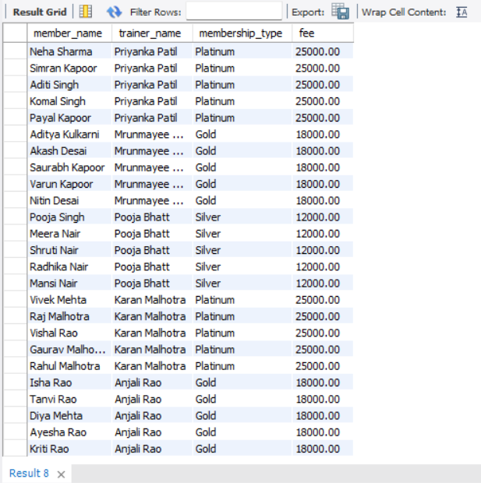

- SUBQUERY
Q1. Find members whose payment is greater than the average payment

SELECT member_name
FROM members
WHERE member_id IN (
SELECT member_id
FROM payments
WHERE amount > (
SELECT AVG(amount)
FROM payments
)
);

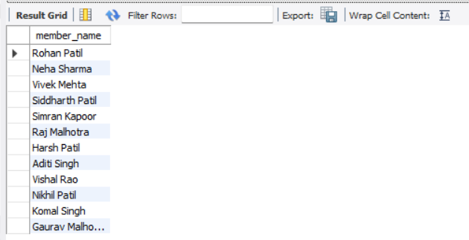

Q2. Find members who have a Gold membership

SELECT member_name
FROM members
WHERE member_id IN (
SELECT member_id
FROM membership
WHERE membership_type = 'Gold'
);

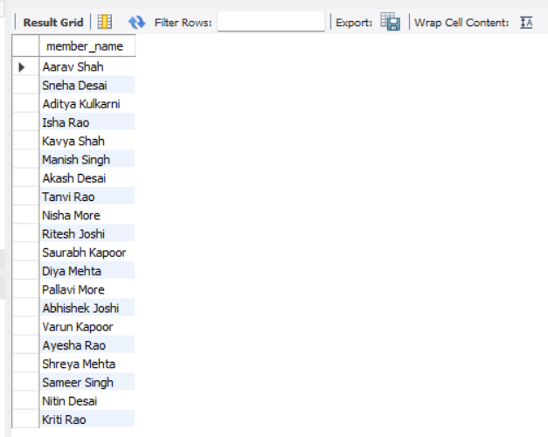

Q3. Find members who have a Platinum membership

SELECT member_id, member_name
FROM members
WHERE member_id IN (
SELECT member_id
FROM membership
WHERE membership_type = 'Platinum'
);

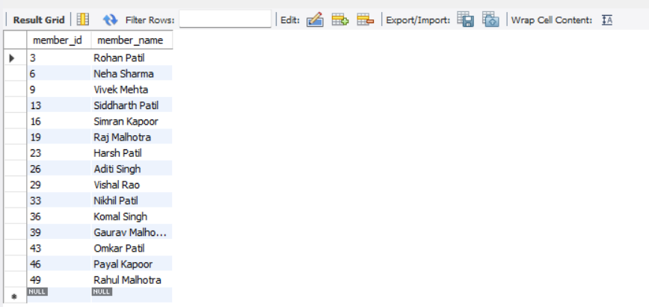

Q4. Find the members who made the highest payment

SELECT m.member_id, m.member_name
FROM members m
WHERE m.member_id IN (
SELECT member_id
FROM payments
WHERE amount = (
SELECT MAX(amount)
FROM payments
)
);

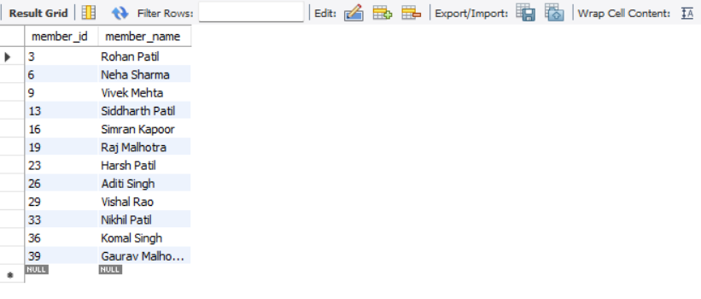

Q5. Find members whose membership fee is greater than the average membership fee

SELECT m.member_id, m.member_name
FROM members m
WHERE m.member_id IN (
SELECT member_id
FROM membership
WHERE fee > (
SELECT AVG(fee)
FROM membership
)
);

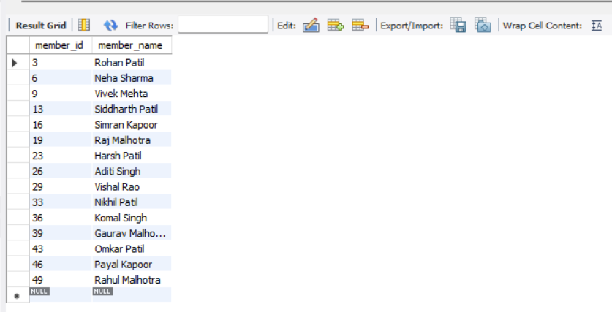

- OTHER QUERIES

Q1. Trainer-wise Member Count

SELECT
t.trainer_name,
COUNT(m.member_id) AS member_count
FROM trainers t
LEFT JOIN members m
ON t.trainer_id = m.trainer_id
GROUP BY t.trainer_name;

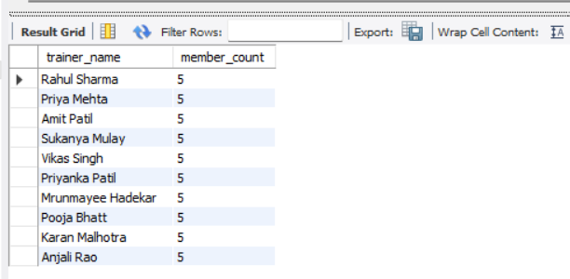

Q2. Membership-wise Revenue

SELECT
ms.membership_type,
SUM(p.amount) AS total_revenue
FROM membership ms
JOIN payments p
ON ms.member_id = p.member_id
GROUP BY ms.membership_type;

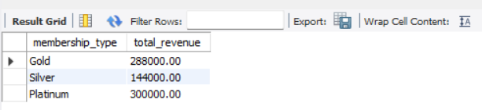

Q3. Total Gym Revenue

SELECT SUM(amount) AS total_revenue
FROM payments
WHERE payment_status = 'Paid';

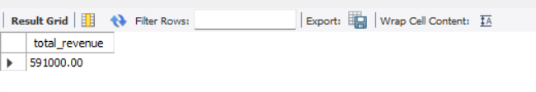

Q4. Display members with their trainer and membership details.

SELECT
m.member_name,
t.trainer_name,
ms.membership_type,
ms.fee
FROM members m
JOIN trainers t
ON m.trainer_id = t.trainer_id
JOIN membership ms
ON m.member_id = ms.member_id;

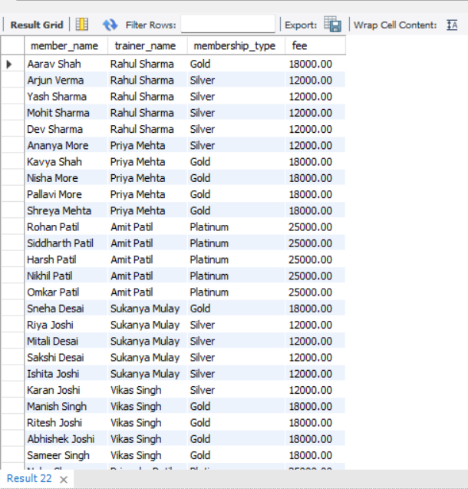
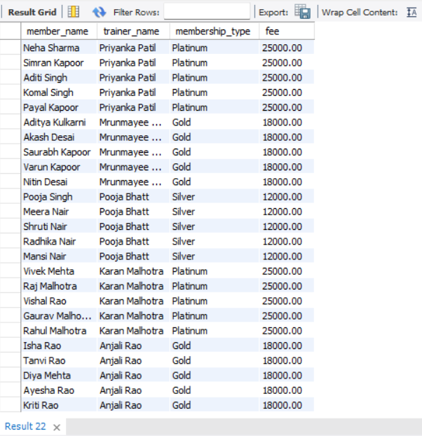

Q5. Find the total number of members assigned to each trainer.

SELECT
t.trainer_name,
COUNT(m.member_id) AS total_members
FROM trainers t
LEFT JOIN members m
ON t.trainer_id = m.trainer_id
GROUP BY t.trainer_id, t.trainer_name
ORDER BY total_members DESC;
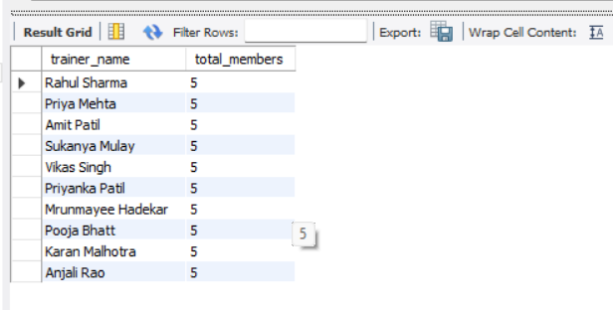

Q6. Find members who have made a pending payment.

SELECT
m.member_name,
p.amount,
p.payment_date
FROM members m
JOIN payments p
ON m.member_id = p.member_id
WHERE p.payment_status = 'Pending';

